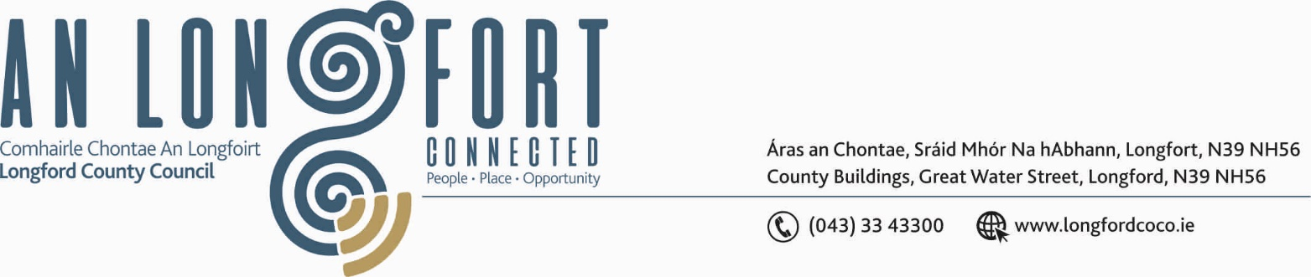

BALLYMAHON MUNICIPAL DISTRICT

Please note meeting will be held in Longford Rugby Club and via Microsoft Teams.

20th November 2020.

To: Each Member of Ballymahon Municipal District.

Dear Member,

You are requested to attend Meeting of Ballymahon Municipal District to be held in Longford Rugby Club on Thursday, 26th November 2020 at
4.00 p.m. to transact business, as set out on the Agenda hereunder.

Yours sincerely,
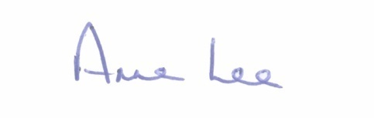

_______________
Anne Lee,
Meetings Administrator.

AGENDA

Prayer before meeting.

1. (i) Confirmation of Minutes of Ballymahon Municipal District
Meeting held on the 24th September 2020 – copy enclosed.
(ii) Confirmation of Minutes of Ballymahon MD Meetings held on the
29th October 2020.

2. Matters arising from Minutes.

3. Declaration of Interest by Members.

4. Management Report - enclosed.

5. Community Grants

6. Keep Well Campaign.

- To note Supplementary Standing Orders – Remote Meetings – adopted at
November meeting of Longford County Council – enclosed.

8. Notices of Motions, submitted by Councillors, as listed hereunder –

Councillor Pat O’Toole.
“I call on Longford County Council to provide funding for repairs to a number of sections of the perimeter wall of Cloncallow Cemetery. Estimate €1350”.
“That in preparation for the installation of Community CCTV cameras in Ballymahon that ducting for the cables is installed when the proposed streetscape works are being carried out.”

“I call on Longford County Council to substantially increase the Community Grant allocations to the Christmas Lights Committees in the the Ballymahon M.D area.”

Councillor Mark Casey.

“That this Council requests Irish Water to extend the sewage main from the New Fire Station in Lanesboro out to Barnacor on the N63, which will take in a number of houses and businesses.”

“That the footpath be repaired at the Church, at Casserlys shop and outside O’Briens Chemist in Lanesborough.”

“That funding should be sought for the replacement of the footpath on the Rathcline Road.”

Councillor Paul Ross.

“That Longford Co Council wash the cobble lock paving outside the 4 old peoples dwelling houses on Granard Street, Edgeworthstown in the interest of public safety.”

“That the trees on Main Street, Barry be removed as they are causing the footpath to rise and are a trip hazard.”

“That the playground at Foxhall be upgraded as it has fallen into poor repair.”

Councillor Colm Murray.

“I call on Longford County Council to enact a process whereby parking bye laws will be introduced in towns and villages across the Ballymahon Municipal District. The current bye laws in the MD are only pertinent to one village thereby leaving standard road markings such as disabled parking spaces, yellow boxes, etc everywhere else in the MD subject to no bye laws and unenforceable by the Gardai.”



